**Date = 1/11/2022**

**Difference between TDM and TEM**

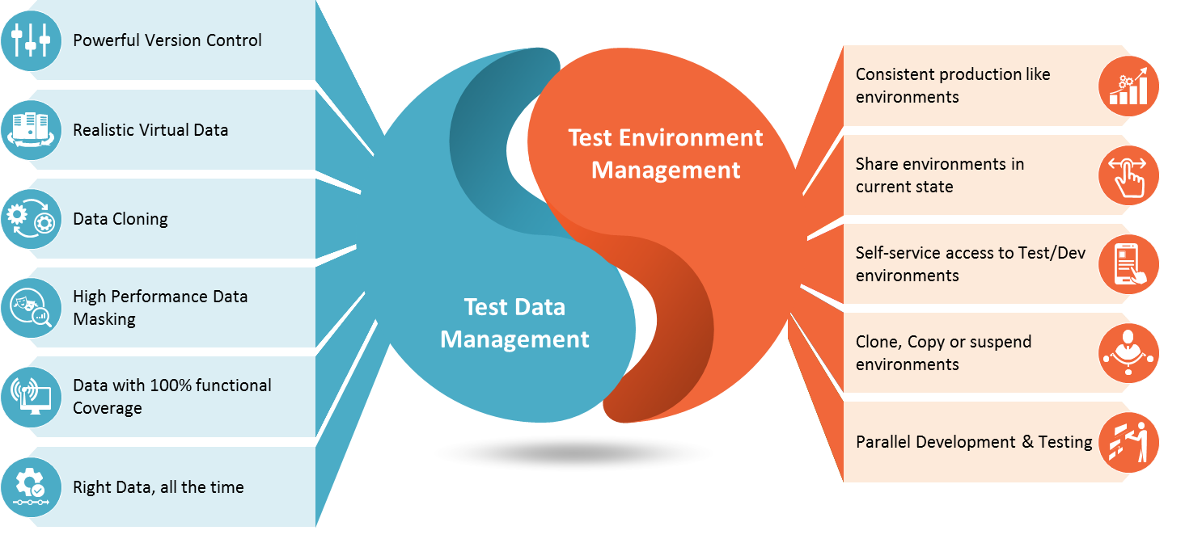

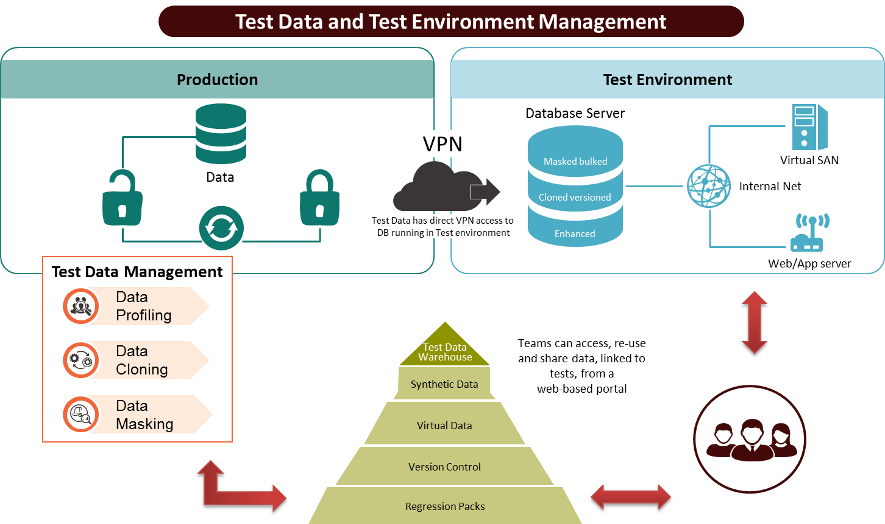

What is Test Data Management?

Test data management (TDM), a sister function of Test Environment Management, is the construction of test data sets that reliably represents an organization’s actual data so that IT teams (developers and testers) can effectively exercise software testing. Tests include Unit Testing, System Testing, Integration Testing, User Acceptance Testing, Performance Testing, and Security Testing.

Test Environments Management

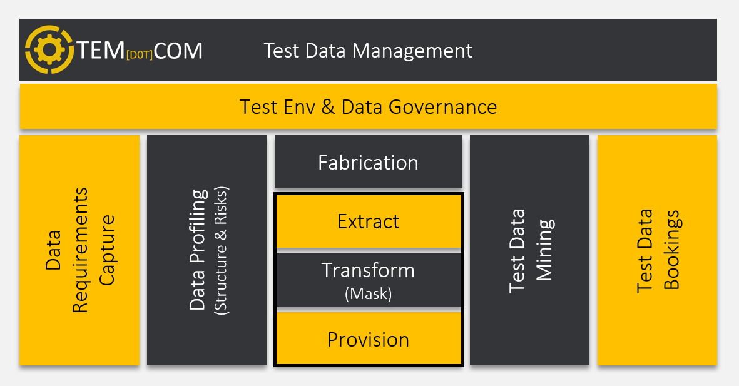

Test Environments Management

Test Environments Management is the act of understanding your production environment and cross-life-cycle test environments. It includes establishing controls to ensure your teams use them effectively and rapidly, service, provision, and delete them on time.

|  |  |
| --- | --- |
| Test Data Management | Test Environments Management |
|  |  |
|  |  |
|  |  |